##### Nelson

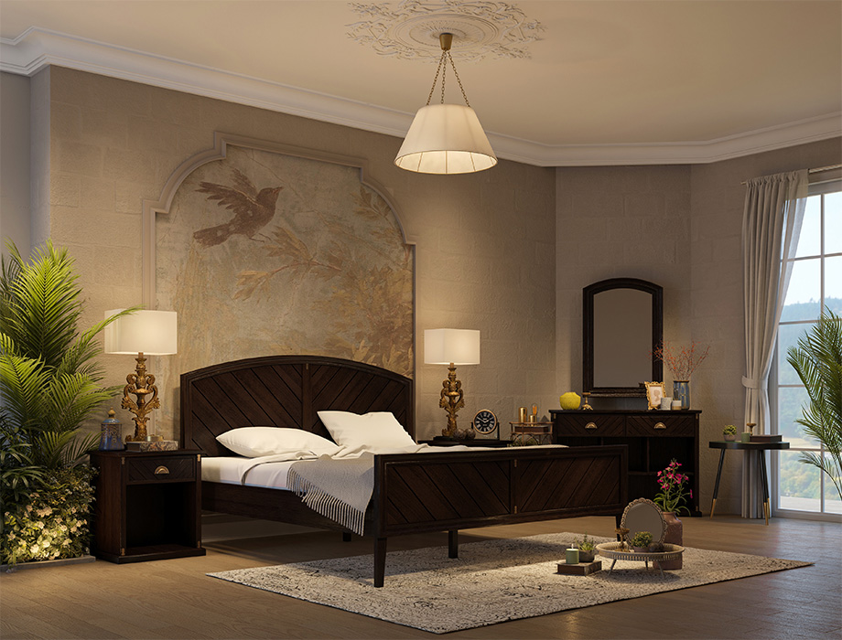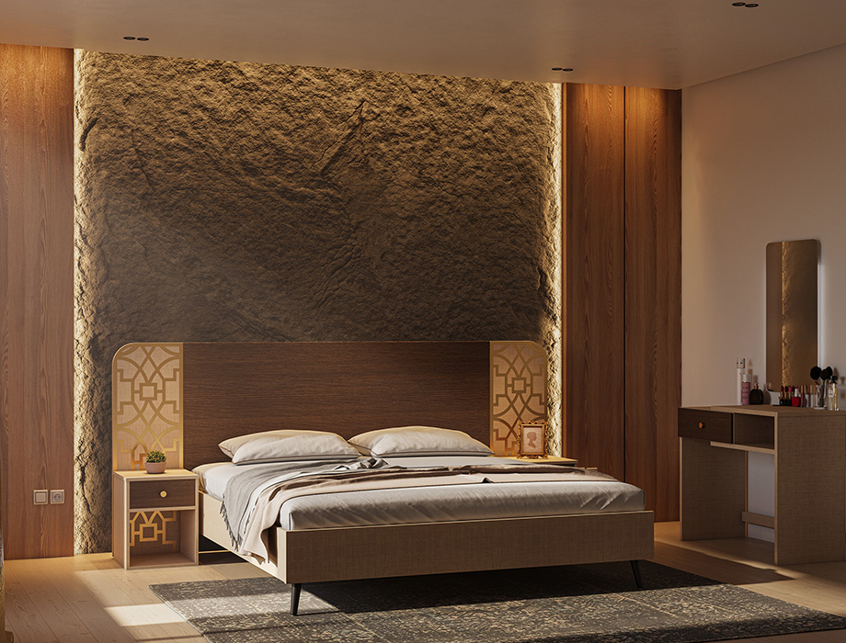

(Bed + Bedside tables + Dresser + Mirror)

### **Specifications:**

**Bed:**

* **Size:**35.4” W x 83” D x 49” H (Inches)
* **Material:** Okoume Wood
* **Finish:** Walnut finish
* **Legs:**Wooden
* **Recommended Mattress Size:** 78” L x 72” W x 8” H – Sold Separately

### **Bedside Table:**

* **Size:**22” W x 19” D x 25” H (Inches)
* **Material:**Okoume Wood
* **Finish:**Walnut finish blended with Golden antique motifs

### **Mirror:**

* **Size:** 27W x 2D x 40H (Inches)
* **Material:**Okoume Wood
* **Finish:**Walnut finish

### **Dresser:**

* **Size:**48” W x 18” D x 34” H (Inches)
* **Material:**Okoume Wood
* **Finish:**Walnut finish

Give your bedroom a classic touch with the delightfully simple Chelsea bed. Featuring an arched headboard with striking diagonal grooves, this bed is a masterpiece of elegance with its appealing design that blends flawlessly with any interior. Robustly constructed from solid Okoume wood with a catalyzed lacquer topcoat, its walnut finish accentuates the unique wood’s natural grain while adding a commanding presence to your bedroom. The matching headboard and footboard are further embellished with antique golden motifs offering a more versatile look while the wooden legs provide stability to the overall design. Pair this luxurious bed with Chelsea bedside tables, a dresser, and a mirror for a completely glamorous look.